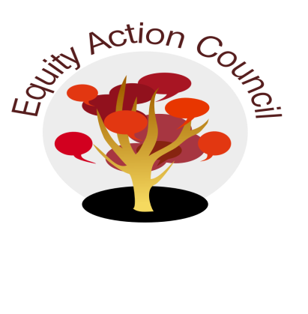
Time | Process | Topic | Facilitator(s)
1:30pm | I | I. Introduction: Welcome and Check in With Participants | Alicia Cortez
1:35pm | I | II. Community Wellness Check ins | Edmundo Norte
2:10pm | I/D | III: Student and Basic Needs Survey:  - Student Survey & Voices | Mallory Newell
2:30 |  | IV: Subcommittee Updates:  - Equity Champion Award  - College Planning  - Upcoming Equity Trainings  - Equity Certification for Classified | Melissa Aguilar
2:50pm | I | V. Announcements  - Upcoming Equity Trainings  - Equity Certification Training for Classified Professionals | Erick Aragon
2:55pm | I | VI. Appreciations | All

EAC Community Agreements
Show up, and choose to be present
Pay attention to what has heart and meaning
Tell the truth without blame or judgment
Be open to outcome, not attached to outcome
From The Four-Fold Way® by Angeles Arrien, Ph.D.

